Architecture and Engineering

Church of Jesus Christ
of Latter-Day Saints
Landscape Management Plan
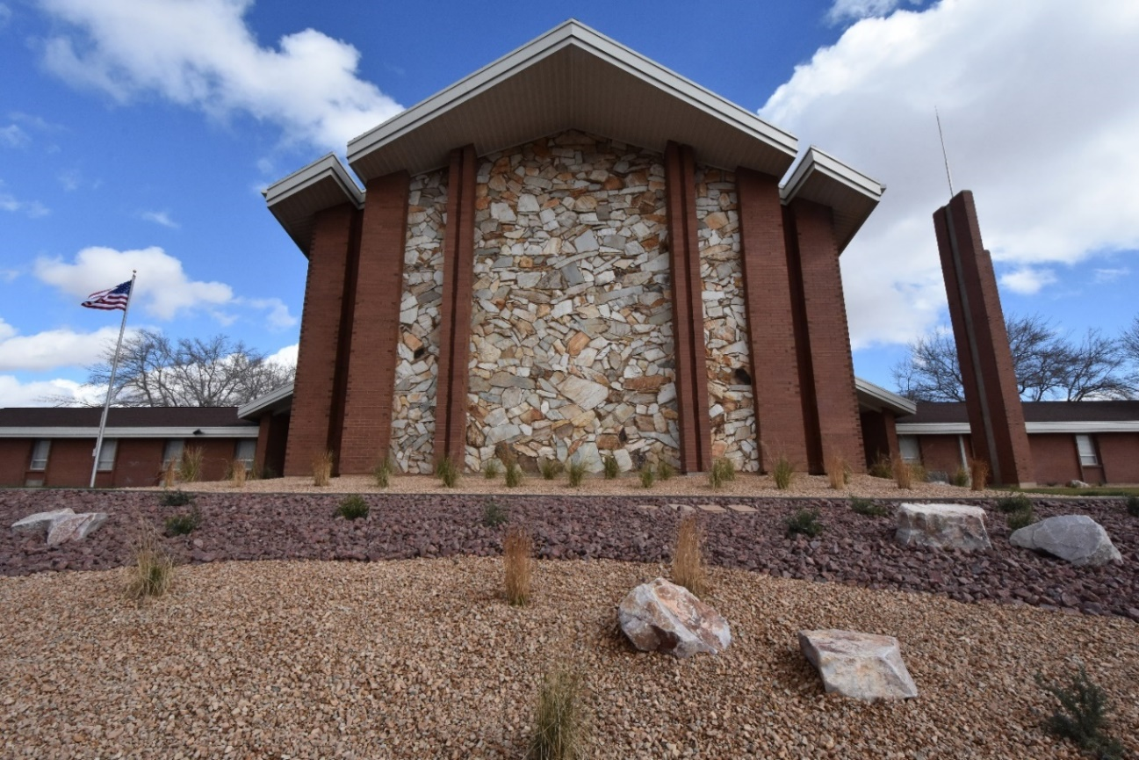

Insert photo of Project building

Edit Document for each Property.
Prior to completion, remove or modify notes in RED.
Change to black if retained.
Date: Month Year
Building Property No: #######
Complete Building Address: #####, #####, #####

Prepared by: Consultant’s Name (Title). Contractor Name (Title)

A template of this document is available for download at http://aec.ldschurch.org/aec/landscape/
Contact David Wright, Church Meetinghouse Facility Department Landscape Architect
with questions or comments (801)240-9478 wrightds@ldschurch.org
Instructions to landscape architects who assemble this document:

- For management consistency, do not change or modify the order of this document.
- Edit portions of document shown in red print. And review black print to verify that it is applicable to this project. All final print to be black.
- Collect contractor required materials and include herein.
- Include landscape architect required materials.
- Update the Table of Contents below as required.
- Remove remaining items in red including these instructions prior to completion.
- Create PDF and deliver to Church Headquarters or Architect to add to as-built library using following instructions http://aec.ldschurch.org/aec/asbuilts/ .

Contents:

Introduction

General Maintenance Guidelines

Local Maintenance Guidelines

Irrigation Section

Planting Section

Irrigation System Approval

Warranty

Completion Signatures

Introduction

The Landscape Management Plan (LMP) is a Facilities Manager’s (FM) quick reference guide for landscape maintenance, and it is created by the project landscape architect in coordination with the landscape contractor. The document is to be used as a guide for training the FM, designated staff, and the maintenance personnel. Church standard specifications and details are the basis for this document, provide additional detailed descriptions, and are located on the Church as-built catalog.

General Maintenance Guidelines

Modify following as required for site. Site-specific, unique guidelines are to be placed in the next section.

Plant Establishment

During establishment care must be taken to ensure the root balls remain moist, but not saturated, until roots extend into the native soil at which time irrigation may be reduced. Do not over-irrigate.

During the first two years, tree trunks should be wrapped with white tree tape such as DeWitt white tree wrap.

Turfgrass

Mow at least weekly at a height of 3 ½ inches or as recommended for specific species.

Fertilize with nitrogen (N) at a rate of 1 pound N per 1000 ft2 in spring, early fall, and late fall. Complete fertilizers (N-P-K) should be used if additional nutrients are required based on soil testing.

Control weeds primarily by keeping the turfgrass vigorous through proper irrigation and fertilization. If needed use broadleaf herbicides in the fall of the year after temperatures have started to cool. Use pre-emergent herbicides in the spring as needed.

Do not catch grass clippings.

While mowing, scout for potential insect or disease problems. Address as appropriate using local USDA Extension Service recommendations (in the United States) or similar.

Maintain grass-free tree circles around each tree so equipment does not damage bark.

Aerate turfgrass annually.

If irrigation restrictions are required, irrigate turfgrass with one-inch of water at least monthly to keep it dormant, but alive.

Mulches

Keep mulched areas weed free by spot spraying with glyphosate or manually removing weeds.

Replace bark mulch as needed to reduce weeds and soil water evaporation. Keep at least 3-inches of mulch in place.

If stone and/or organic mulches slide downhill in steep areas, they will need to be restored to their original location and depth.

Clean stone mulch areas of organic material by blowing.

Due to their high visibility, do not permit dead or dying material to remain in mulched areas. Remove as quickly as possible and replace as opportunity allows.

Shrub beds

Shrubs do not need as much fertilizer as lawns and should be given 1 pound of N/1000 ft2 as a complete, slow-release fertilizer annually in the early spring.

Specific pruning or dead-heading efforts should be done as described in the individual plant material specifications. While some plants will need to be sheared back to the base each year (i.e. ornamental grasses and bluebeard), none should be sheared into geometric shapes. Strive to maintain the natural form of the shrub.

Yuccas should have dead leaves removed but should never be pruned.

Ornamental Grasses

Ornamental grasses should be left intact until late winter to capitalize on their winter appearance. Grasses should be sheared back to the base in late winter or early spring prior to new growth occurring.

With age, ornamental grasses may begin to spread and become hollow in the center, at that time division of the grasses should be considered.

Trees

Trees should be examined at least every three years and pruned as needed by an International Society of Arborists certified arborist.

Trees in lawn and shrub beds should not require additional, separate fertilization from the shrubs and lawns.

Mulches should be placed up to, but not touching, tree trunks.

Soils

If there are indications of nutrient deficiencies the soil should be tested prior to adding supplemental fertilizer. Additional fertilization should be based on soil test recommendations. Periodically adding nitrogen to lawns is a standard practice and does not require a soil test.

Soil test results should be recorded in the LMP.

Winter Care

Snow should be pushed onto lawn or mulched areas, not into shrubs or trees

Ice melt should be used sparingly. Excessive applications may damage plant material

Avoid winter or dry season desiccation of evergreen plants

Irrigation System

Spring startup

Close all drains

Clean filters

Turn on water at point of connection

Verify controller and sensors are operating. Replace batteries.

Charge system and run heads.

Check for breaks, leaks, misaligned heads, and plugged in-head filters

Repair as needed

Operating the system

Set up the controller for spring and use as designed. Do not shut the system off or go to a manual option. Learn how to use it.

Verify controller operation and adjust at least monthly by monitoring sprinklers and observing plant growth

Use the cycle/soak application feature in any area where irrigation water runs off the landscape

Clean filters as needed

Repair leaks as quickly as possible to conserve water

Adjustments to the WeatherTRAK system with establishment of plants should consist of increasing the soil depth for irrigation from 4-inches to 6-inches to 8-inches. Plants should be observed throughout the transition to ensure they adapt and are not damaged.

Create a detailed report of controller settings for each property and submit to owner

Winterization by blowing out lines

Turn off water at point of connection

Connect air compressor downstream from the backflow preventer

Close valves to prevent air from passing through and damaging the hydrometer

Run air compressor at 30 PSI and 185 cfm. Higher pressures and volumes will damage irrigation components.

Cycle through stations until misting stops. Repeat.

Turn controller off

Open manual drains and manual valves

Drain, wrap, protect, or remove any backflow device exposed to freezing temperatures using manufacturer’s recommendations and best practices.

Drain and remove pumps for storage.

Drain filters using manufacturer’s recommendations.

Check sprinkler heads to make sure they are below sidewalk and curb levels and not vulnerable to snowplow damage. Lower heads to proper elevation.

If winterization is done by a contractor, they should notify owner when completed

Cleanliness

Debris such as pruned material should be picked up as a given project proceeds. The landscape should be clean at the end of each workday.

Fallen leaves should be collected and removed from lawns, rock mulched areas, and hardscaping

Sidewalks should be kept clean of grass clippings, fertilizer prills, or other materials

Weed beds weekly

Local Maintenance Guidelines

Local Requirements

List unique guidelines to this meetinghouse/property such as winter watering, unique plants or growing conditions, unique soil, mulch or fertilizing requirements, unique construction implications, unique irrigation requirements, etc.

Irrigation Section

Estimated Water Use Calculations
Provide water use calculations using local ordinances. If local ordinances are not required or available, use other industry approved methods such as the US EPA Water Budget tool.

Plant Establishment Watering Schedule
This section is for plants that are in the process of being established. Edit the following table as required for site specific conditions. The completed cells are provided as possibilities. The landscape architect and contractor should adjust as necessary for this site.

Zone | Irrigation Type | GPM (LPM) | Precipitation Rate (Inches (mm)/hour) | Water Days per Week | Run Times (Minutes) | Cycle Time | Soak Time | Plant Type | Soil Type | Slope | Sun Exposure
1 | Spray | 35.6 | 2.19 | 7 | 10 | 5 | 30 | Lawn | Clay | Steep | Full sun
2 | Rotor | 38.8 | 0.41 | 7 | 30 |  |  | Lawn | Loamy Clay | Gentle | Full sun
3 | Rotary | 30.4 | 0.45 | 7 | 30 |  |  | Lawn | Loamy Clay | Gentle | Part Shade
4 | Tree Dripline | 3.1 | NA | 7 | 40 |  |  | Trees | Clay | Gentle | Full sun
5 | Point Source Drip | 2.8 | NA | 7 | 30 |  |  | Shrubs | Clay | Gentle | Shade
[Additional zones as needed]

Established Plant Watering Schedule
This section is for plants that are established. Edit the following table as required for site specific conditions. The completed cells are provided as possibilities. The landscape architect and contractor should adjust as necessary for this site.

Zone | Irrigation Type | GPM (LPM) | Precipitation Rate (Inches (mm)/hour) | Water Days per Week | Run Times (Minutes) | Cycle Time | Soak Time | Plant Type | Soil Type | Slope | Sun Exposure
1 | Spray | 35.6 | 2.19 | 3 | 15 | 5 | 30 | Lawn | Clay | Steep | Full sun
2 | Rotor | 38.8 | 0.41 | 3 | 40 |  |  | Lawn | Loamy Clay | Gentle | Full sun
3 | Rotary | 30.4 | 0.45 | 3 | 55 |  |  | Lawn | Loamy Clay | Gentle | Part Shade
4 | Tree Dripline | 3.1 | NA | 1 | 60 |  |  | Trees | Clay | Gentle | Full sun
5 | Point Source Drip | 2.8 | NA | 1 | 45 |  |  | Shrubs | Clay | Gentle | Shade
[Additional zones as needed]

Irrigation System Record and As-Built Drawings
Edit list as required.

Drawing Title | Description | Sheet Number | Drawing Date
Irrigation Plan | Overall irrigation plan | LI101 | 8/4/23
Irrigation Plan | North irrigation plan | LI102 | 8/4/23
Irrigation Plan | South irrigation plan | LI103 | 8/4/23
Tree Irrigation Exhibit | Tree irrigation plan | LI104 | 8/4/23
Color-Coded Irrigation Plan | Plan with zones color-coded | LI101 | 8/4/23

Insert 11x17 plan(s) immediately following this paragraph.
Insert 11x17 irrigation plan(s) here.

Irrigation System Components

Insert the Irrigation Components for this project, often from the contractor’s irrigation submittal and/or Irrigation Plan equipment schedule. See sample found at this site.

Insert 8.5 x 11 sheets immediately following this page.

Insert 8.5 x 11 sheets here.

Planting Section

Construction Data

Enter Data applicable to this project.

Water Source

List as culinary, secondary, or reclaimed with water agency or source.

Water Restrictions

List any known restrictions at time of installation.

Soil Conditions

Provide name of laboratory and test results.

Insert 8.5 x 11 “Topsoil Testing Report” immediately following this page.

Insert “Topsoil Testing Report” here.

Planting Plan Record Drawings

Drawing Title | Description | Sheet Number | Drawing Date
Planting Plan | Overall planting plan | LP101 | 8/4/23
Planting Plan | North planting plan | LI102 | 8/4/23
Planting Plan | South planting plan | LI103 | 8/4/23

Insert 11x17 planting plan(s) immediately following this page.

Insert 11 x 17 planting plan(s) here.

Planting Components

Add specific Landscape components and sources such as mulch, boulders, pavers, edging, seed mixes, etc.

Plant Materials

Add Plant List and plant data sheets for this Project.
Insert 8.5 x 11 plant list and plant data sheet(s) immediately following this page.

Insert 8.5 x 11 plant list and plant data sheets here.

Irrigation System Approval

Irrigation System Approval

Add landscape architect generated document as described in “Section 32 8423 Underground Sprinklers – Controllers Not included.” If able to keep fully legible, preparer may include below this section introduction or as a separate 8.5 x 11 page following this page.

Warranty

Contractor warranty language

Insert contractor warranty document immediately following this page.

Insert 8.5 x 11 contractor warranty document sheet(s) here.

Completion Signatures

Have FM and contractor(s) date and sign certificate listed below.

THE ESTABLISHMENT PERIOD MAINTENANCE PLAN WAS SUBMITTED TO THE FM MANAGER FOR THIS SITE ON ____________________ (DATE).

THE ESTABLISHMENT PERIOD SHOULD EXTEND FOR A PERIOD OF ONE YEAR, BEGINNING ON ______________ (DATE) AND ENDING ON ______________ (DATE).

THE FACILITIES MANAGER HAS RECEIVED TRAINING FOR LANDSCAPE MAINTENANCE DURING THE ESTABLISHMENT PERIOD AND A COPY OF THE INSTRUCTIONS ARE ATTACHED TO THIS DOCUMENT.

_____________________________________________
FACILITIES MANAGER SIGNATURE

_____________________________________________
LANDSCAPE CONTRACTOR SIGNATURE

_____________________________________________
CATEGORY MANAGEMENT SIGNATURE

